ICS 103 – Computer Programming in C
Spring Semester 2011/2012 (112)

Lab# 5 Repetition Statements
Objectives:
Learn C repetition statements by covering the following topics:
- while loops
- do-while loops
- for-loops
- Nested loops

- while-statement
A while-statement is used to execute a statement or a compound-statement zero or more times as long as the while-condition is true:
while(condition)
while-body

The while-body can be a simple statement in which case it must be terminated by a semicolon or it may be a compound-statement in which case it should not be terminated by a semicolon:

Simple statement while-body | Compound-statement while-body
while(condition)  statement; | while(condition)  compound-statement
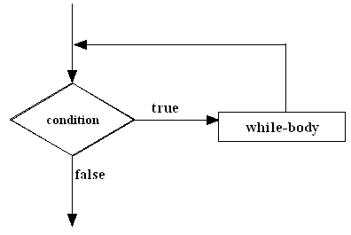

Examples:
while-loop | output
int n = 1;  while(n <= 10){  printf("%d ", n);  n += 2;  } | 1 3 5 7 9
int k = 12;  while(k > 6)  printf("%d ", k--); | 12 11 10 9 8 7
int num = 2;  printf("number\tsquare root\tsquare\n");  while(num <= 5){  printf("%d\t%.2f\t%2d\n", num, sqrt(num), num * num);  num++;  } | number square root square  2 1.41 4  3 1.73 9  4 2.00 16  5 2.24 25
- Sentinel controlled loops
In a program, a sentinel is a value that marks the end of a series of data values; but is not a data value itself. Sentinels may be used to control loops:

Example: Write a C program fragment that prompts for and reads student grades in a quiz. It then calculates and displays the average. Use a negative value as the sentinel.

int count = 0;
double grade, sumOfGrades = 0.0;
printf("Enter grade#%d (-ve value to terminate)\n", count+1);
scanf("%lf", &grade);
while(grade >= 0){
count++;
sumOfGrades += grade;
printf("Enter grade#%d (-ve value to terminate)\n", count+1);
scanf("%lf", &grade);
}
if(count == 0)
printf("Error: No valid grade entered\n");
else
printf("Average = %.2f\n", sumOfGrades / count);

- do-while statement
A do-while statement is used to execute a statement or a compound-statement one or more times as long as the do-while condition is true:

do
do-while body
while(condition);
The do-while body can be a simple statement in which case it must be terminated by a semicolon or it may be a compound-statement in which case it MUST NOT be terminated by a semicolon:

Simple statement do-while body | Compound-statement do-while body
do  statement;  while(condition); | do {  compound_statement  } while(condition);
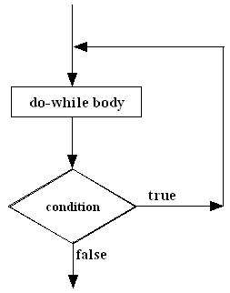

Examples:
do-while loop | output
int n = 1;  do{  printf("%d ", n);  n += 2;  } while(n <= 10); | 1 3 5 7 9
int x = 25;  do  printf("%d ", x -= 5);  while(x > 0); | 20 15 10 5 0

Example: A do-while loop can be used to validate input

int n;
do{
printf ("Enter an integer number in [10,100] interval >");
scanf("%d",&n);
if(n<10 || n>100)
printf("Sorry wrong input, try again\n");
}while (n < 10 || n > 100);
printf("Now your input is correct");

A do-while loop can be used in a menu driven program. The example shown below will continue running as long as the user did not enter the number 5.

#include <stdio.h>
void menu(void); // function prototype
int main(void){
int choice;
do{
menu();
printf("Enter your choice >");
scanf("%d",&choice);
// Here come the statements to do the different tasks
} while (choice != 5);
return 0;
}
void menu(void) {
printf("1-Addition\n");
printf("2-Subtraction\n");
printf("3-Multiplication\n");
printf("4-Division\n");
printf("5-Exit\n");
}

- for-statement
A for-statement is usually used to repeat a statement or a compound-statement if the number of repetitions is known. The body of a for-loop may be executed zero or more times.

for(initialization; condition; update)
for-body

The for-body can be a simple statement in which case it must be terminated by a semicolon, or it may be a compound-statement in which case it should not be terminated by a semicolon:

Simple statement for-body | Compound-statement for-body
for(initialization; condition; update)  statement; | for(initialization; condition; update)  compound_statement
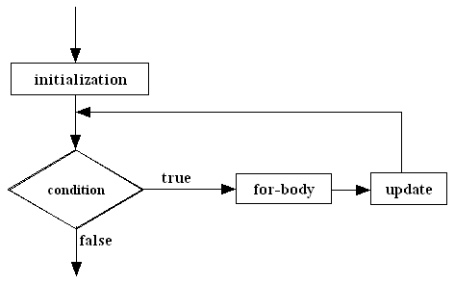

Examples:
for-loop | output
int k;  for(k = 7; k <= 12; k++)  printf("%d ", k); | 7 8 9 10 11 12
int x ;  for(x = 8; x > 2; x--)  if( x % 2 == 0)  printf("%d is even\n", x);  else  printf("%d is odd\n", x); | 8 is even  7 is odd  6 is even  5 is odd  4 is even  3 is odd

Loops like the ones in the above examples in which a variable is used to control the number of
repetitions of the loop are called counting loops.

- Equivalent loops
A loop can always be converted to an equivalent loop of a different type. Examples:

loop | equivalent loop
for(initialization;condition; update)  {  statement1;  statement2;  . . .  statementN;  } | initialization;  while(condition)  {  statement1;  statement2;  . . .  statementN;  update;  }
do{  statement1;  statement2;  . . .  statementN;  update;  } while(condition); | statement1;  statement2;  . . .  statementN;  update;  while(condition){  statement1;  statement2;  . . .  statementN;  update;  }

For example the following do-while loop:
int n = 1;
double x = 0, s;
do{
s = 1.0 / (n * n);
x = x + s;
printf("x = %f\n", x);
n++;
} while(s > 0.01);

is equivalent to the while-loop:

int n = 1;
double x = 0, s;
s = 1.0 / (n * n);
x = x + s;
printf("x = %f\n", x);
n++;
while(s > 0.01){
s = 1.0 / (n * n);
x = x + s;
printf("x = %f\n", x);
n++;
}

- Nested loops
A loop statement may contain in its body one or more loop statements.

Examples:

Nested loops | output
int m, n;  for(m = 5; m >= 1; m--){  printf("m is now %d\n", m);  for(n = 1; n <= 4; n++)  printf("n = %d ", n);  } | m is now 5  n = 1 n = 2 n = 3 n= 4  m is now 4  n = 1 n = 2 n = 3 n= 4  m is now 3  n = 1 n = 2 n = 3 n= 4  m is now 2  n = 1 n = 2 n = 3 n= 4  m is now 1  n = 1 n = 2 n = 3 n= 4
int i,j;  for(i=1;i<=9;i++){  for(j=1; j<=i; j++){  printf("%d,",j);  }  printf("\n");  } | 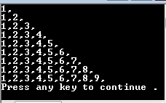

Example: Write a C program that prompts for and reads three quiz grades for each student in a class of four students. The program then computes and displays the average for each student. Your program must be easily modifiable to handle any number of students and quizzes.

#include <stdio.h>
#include <stdlib.h>
#define NUMSTUDENTS 4
#define NUMQUIZES 3
int main(void){
double grade, studentTotal, studentAverage;
int m, n;

for(m = 1; m <= NUMSTUDENTS; m++)
{
studentTotal = 0.0;
for(n = 1; n <= NUMQUIZES; n++)
{
printf("Enter QuizGrade#%d for student#%d\n", n, m);
scanf("%lf", &grade);
studentTotal += grade;
}
studentAverage = studentTotal / NUMQUIZES;
printf("The average for student#%d is %.2f\n", studentAverage);

}

system("pause");
return 0;
}

Exercise: Modify the above program such that it also computes and displays the class average.

Laboratory Tasks

Task 1:
Using sentinel controlled loop (while or for loop), write a program that reads a radius from the user and displays the area and circumference of the circle with that radius. This task is repeated until the user types 0. Assume that the radius is in centimeters. Use a named constant PI with value 3.1429

Sample run:
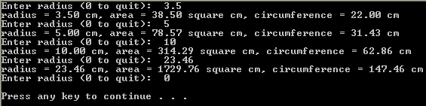

Task 2:
Using a while loop, write a C program to display a positive integer number typed by the user in reverse.

Sample run:
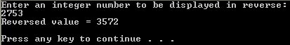

Hint: Use remainder of division by 10 and division by 10.

Task 3:
Using nested for loops, write a C program to print the pattern shown in the sample runs below on the screen.

Sample runs:
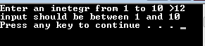 | 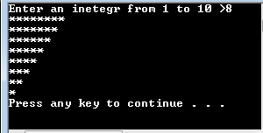

Task 4:
Using a do-while loop, write a C program to check that the user has typed a letter. The program must not stop until the user types a lowercase or uppercase letter.

Note: Use getchar( ) or fflush(stdin) to skip the new line character after reading each character.

Sample runs:
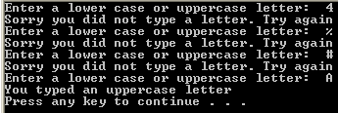 | 